Project 2: Title
(Edit this document as needed)

Partner 1: _______________________________

Partner 2: _______________________________

Partner 3: _______________________________ (if needed)

Brief description of your project. Describe your inputs and outputs. Include an explanation of what parts of the course were relevant to your project. For example, if you used a high pass filter, explain why it was needed and why you picked the specific corner frequency.

Explain why you found this particular project interesting.

Include a schematic of your project hardware. The schematic must be one you implemented by hand or in LTspice. You cannot use an image copied from another source for your schematic. Make sure you indicate the components you used and their values where appropriate.

(If needed) Include a software description. If you implemented a software component, include pseudocode or a flowchart describing your code.

Include measurement plots demonstrating your hardware working as expected. As appropriate, you should measure input values and output values, adding annotations that describe the design characteristics. If you circuit has subsystem components, for example an amplifier/555 timer, include plots demonstrating that the subsystem is working correctly. Make sure you provide a brief description of each plot, no more than a few sentences.

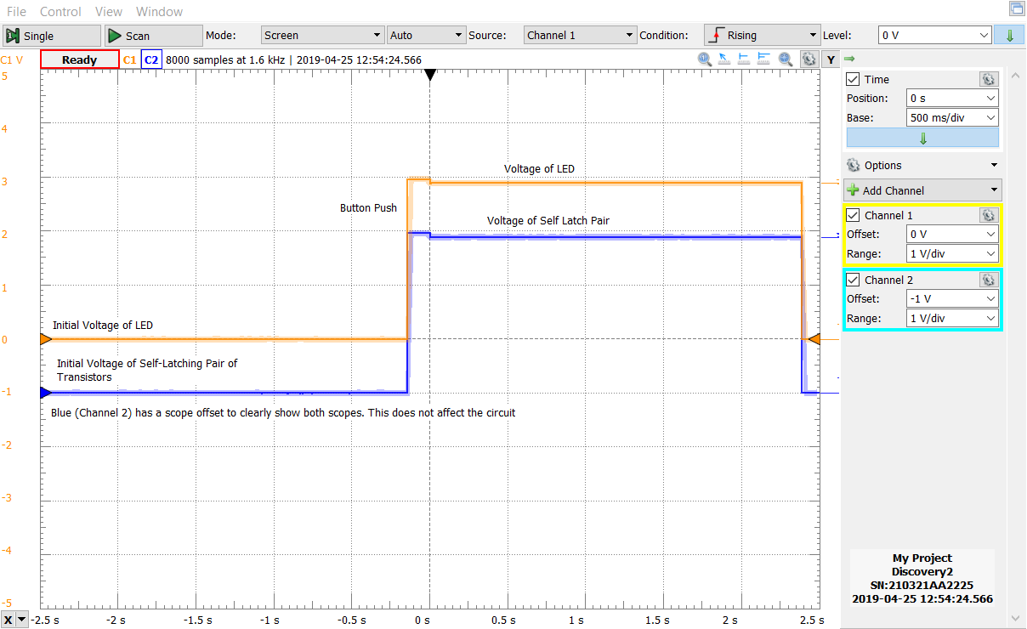
This is demonstrating the properties of the self latching pair of NPN and PNP transitors that keep the LED on even after the button push. After the button is pressed the LED turns on and so do the transistors, they keep the LED turned on until the rest of circuit turns it off.

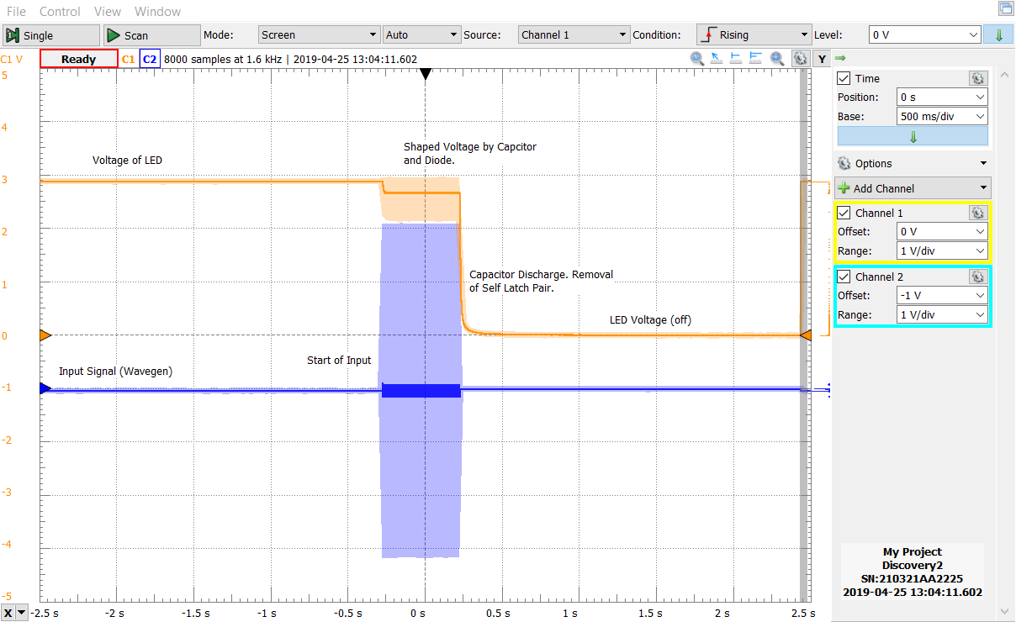
This is a direct comparison between the Voltage of the LED and the Input Signal. Here the input operates at 10kHz and 3V. The LED turns off after the input signal as shown in the graph.

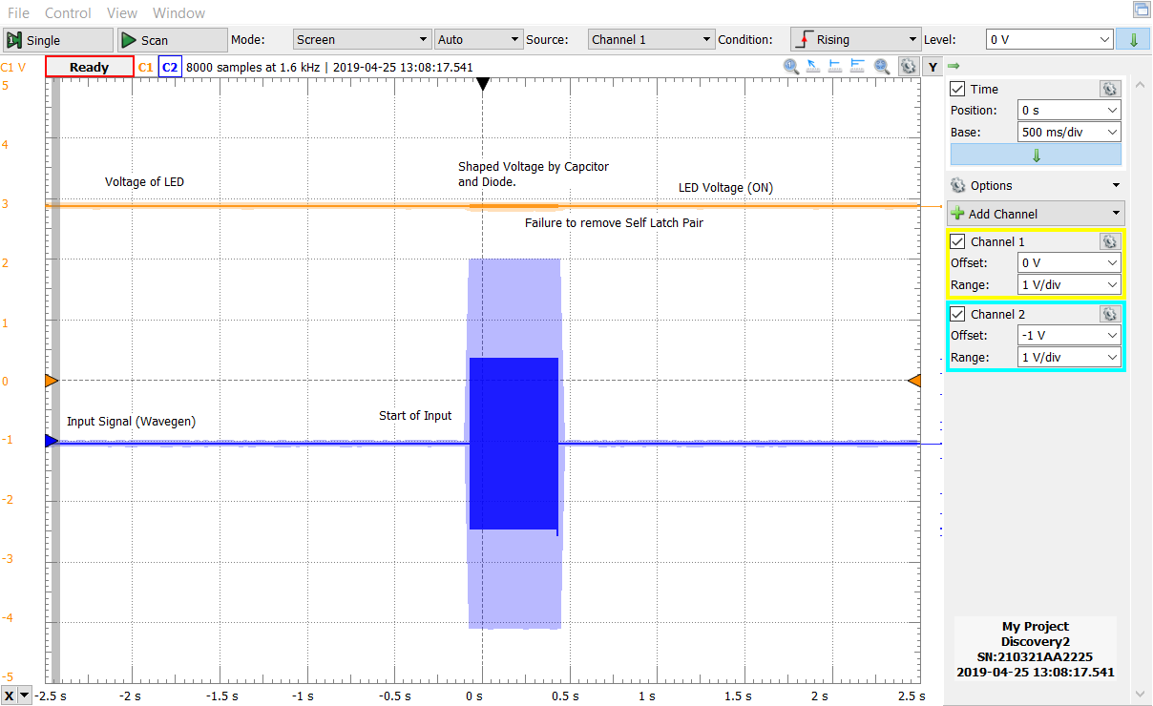
This is a direct comparison between the input signal and the voltage of the LED. The input is at 1kHz, and as shown in the graph, does not have it’s signal pass to turn off the LED. It fails. (condition)

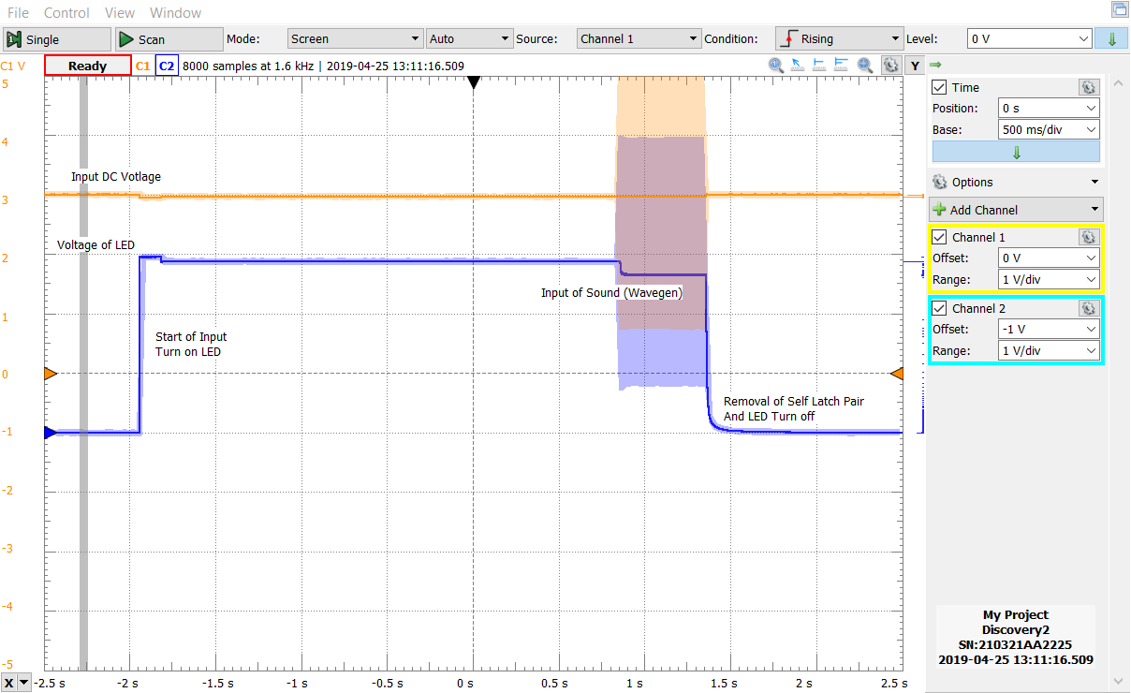 This is the general case showing how a 3V 10kHz signal of “sound” affects the LED versus the Input Voltage. The LED does turn off as expected.
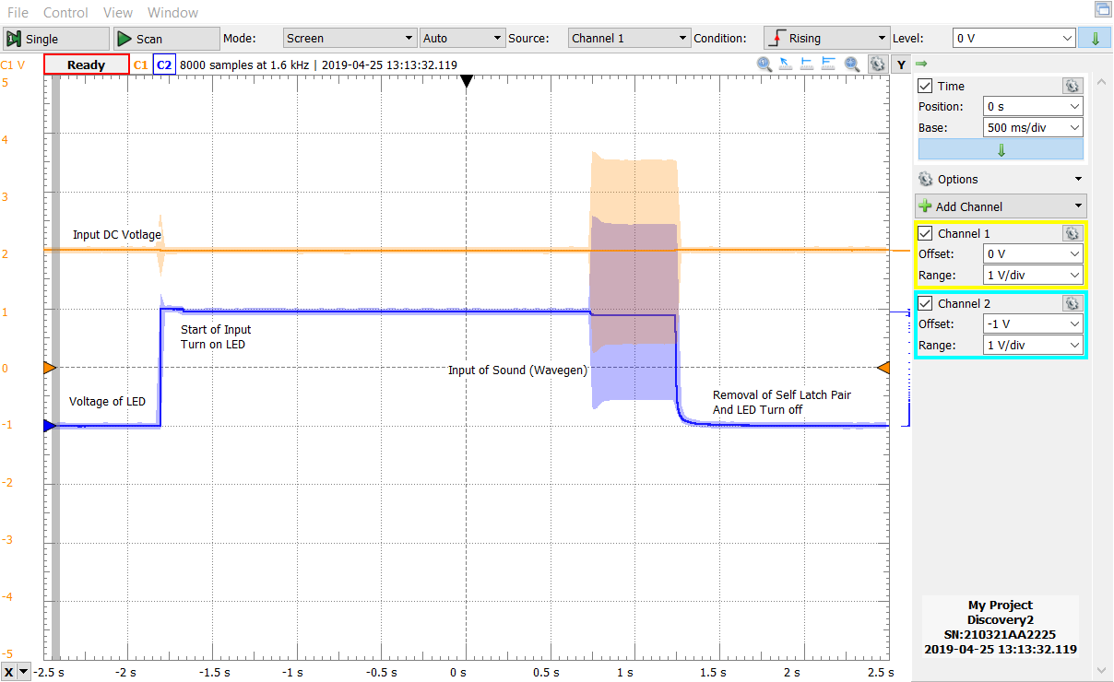
This graph is showing the wavegen operating at 2V peak to peak. Because the frequency did not change and the voltage was high enough, the LED still turned off.(condition)

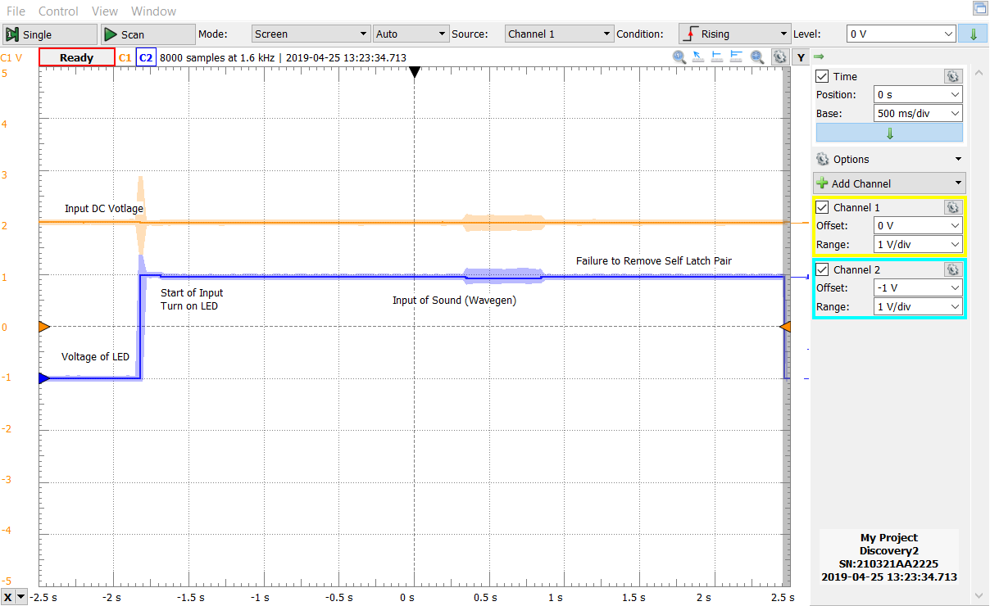
This graph shows that the input signal has to be a certain voltage threshold as well. Here the Input Signal from the Wavegen was a 1V peak to peak. It did not turn off the LED. (condition)

(If needed) Include simulation results. If you implemented a project that you could simulate in LTspice or another software package, include simulation results along the same type as the measurement results discussed above. This part will receive significant weight if you did not get your project working correctly.

Include plots demonstrating your project working under different conditions. For example, change the power settings, change the frequency of operation, etc. You do not need as many plots, just one or two verifying that your project has some range of operation where it performs as expected.

Verification by TA/Instructor of successful completion of project. _______________

